Research Proposal
Liminal Spaces and the Uncanny Valley:
An Interdisciplinary Virtual Reality and Psychology Experimental Research Design

Aaron Chen, Ethan Wang, and James Kerrane
Peak to Peak Charter School
Science Research Seminar Honors
Ms. Ilse Meiler, Ms. Carla Flanhofer, and Mr. Robert Hettmansperger
December 6, 2023

Rationale
Our study tackles how structural changes in expected environments can lead to an "uncanny valley" effect for a space, which is a reported unease from and what makes a space either comfortable or uncomfortable for those occupying that space (Diel & Lewis, 2022). We will change the organization of objects in different virtual reality environments in an organized or an unorganized manner. These structural changes in the environments, such as soup cans on the ground of a supermarket or overturned desks in a school environment will lend to the "uncanny valley" effect of an otherwise known space by highlighting a discrepancy in expectations. The background for our research problem comes from the understanding of liminal spaces which is often associated with spaces that cause some sort of discomfort or unease (Mauro, 2021). This research is important because, as people are coming back from COVID-19, many people are very unwilling to go back in person and the purpose of this research is to help employers, school personnel, and people manage public spaces to increase the comfort and the amount of people returning to their locations.
Developments in virtual reality (VR) technology provides a new experimental framework for prototyping, designing, and implementing psychology experimental design pitches. The ability to create virtual worlds allows researchers to conduct experiments that are unfeasible or impossible in physical reality, creating a new frontier for psychological experimental design (Brookes et al., 2020). Psychological questionnaires in response to virtual reality experiences have shed insight on how virtual reality can be used as a tool in psychological experimental design (Nijland et al., 2021).
In the four Psychology course sections at Peak to Peak Charter School, students create their own proposal for a psychological research project design featuring virtual reality to test a psychology concept. These designs are pitched to each class section, and the class votes on an experimental design to pursue further. Through this process, four experimental design pitches were brought to our team to decide on an experimental design to prototype and bring to virtual reality. We chose a case study experiment out of this process by Reema Patadia to modify and implement into a virtual reality study, which led to our study of the uncanny valley effect for environments.
We use a case study experiment to show the feasibility of virtual reality technologies in creating student-driven psychological experimental design environments. We show that through the use of video game engines such as Unity, experimental design frameworks such as UXF (Brookes et al., 2020), and a research pitch design process from psychology students, virtual reality can be an effective tool to prototype psychology research designs.

Study Framework and Objectives

Research Question
Does the organization of an otherwise known public space cause users to feel unsettling feelings?

Hypothesis
- People placed in spaces where the objects appear scattered or recently used will spend less time in those spaces then people placed in spaces where the objects are neatly organized.
- People placed in spaces where the objects appear scattered or recently used will feel more discomfort than people placed in spaces where the objects are neatly organized.

The organization of objects in virtual reality environments indicating a discrepancy in expectations of a person in an environment studies the "uncanny valley" effect of an otherwise known space. By turning common environments into liminal space, unsettling feelings like unease can be measured with the amount of time someone spends in a room before moving onto the next room, and with the perceived unease of a participant through a post-experiment survey.

Engineering Goal
Our engineering goal is to create a virtual reality (VR) simulation that creates a symbolic representation of real life spaces to allow for accurate data collection on a prediction about how people would react to similar situations in real life.

Methodology and Safety Protocols

Procedure
The procedure at the beginning is the same for both control and experimental groups. Participants will enter the program and the program will automatically decide, using a pseudorandom generator (Unity's Random class), whether they are placed in the control or experimental group. Game engines like Unity cannot generate fully-random numbers, but pseudorandom numbers are designed to be used in game settings and are acceptable for this purpose (Unity - Scripting API, n.d.). This will reduce potential bias by a blind study, because the procedure will be followed by the researcher without the participant or the researcher knowing which group they are a part of.

Script for researchers:
- Read the following to each participant: "Hello, thank you for participating in today's VR experiment. In this experiment, you are going to enter three spaces modeled after real life places in virtual reality. You will have complete freedom to explore the space and when you are ready to move to the next room you will press any button on your controller. After you have pressed the button you will be transported to the next room until there are no rooms left. Participation in this experiment is voluntary and you will not be penalized for participating or exiting the experiment at any time. Please read and sign the informed consent form if you consent to be a part of this research study."
- The participant will be shown a guide on the controls for how to move around in the experience (Appendix C) and how to move to the next room using the buttons on their controller.
- The participant will put their headset on and click a "Start" button, at which point the program will use a pseudorandom number generator to randomly assign participants into either a "Control" or an "Experimental" group.

Control
- The VR experience will load pseudorandomly into one of three environments: An organized supermarket, classroom, or office environment. Once the environment loads, the total time in each environment before moving onto the next environment will be recorded by the game.
- The same process will be repeated for all three spaces and the times will be recorded for each to be compared to the experimental group.
- The experiment concludes after ten minutes have elapsed or the participant has chosen to move on after the third space.
- A comfort survey will be administered inside of the headset (Appendix D), where participants will be able to respond by clicking buttons on the controller.
- The participant will be thanked for their participation and provided the debrief (Appendix B)

Experimental
- The VR experience will load pseudorandomly into one of three environments: A disorganized supermarket, classroom, or office environment. Once the environment loads, the total time in each environment before moving onto the next environment will be recorded by the game.
- The same process will be repeated for all three spaces and the times will be recorded for each to be compared to the experimental group.
- The experiment concludes after ten minutes have elapsed or the participant has chosen to move on after the third space
- A comfort survey will be administered inside of the headset (Appendix D), where participants will be able to respond by clicking buttons on the controller.
- The participant will be thanked for their participation and provided the debrief (Appendix B)

Risk and Safety
For the researchers there is no particular risk outside of any harm caused by testing in VR such as nausea or motion sickness. Researchers will follow the procedures of the place the experiment is being conducted (usually Peak to Peak Charter School), and the room supervisor for safety precautions if a participant is showing signs of sickness.

Data Analysis
The data that we will collect will be the times that participants spend in each room and also the results of a survey conducted after participation that asks about comfort levels (Appendix D). We will first compare the times from the experimental group to the control group in order to see how the amount of time that someone spends in each room is affected by the orientation of objects in the spaces. We will then compare the survey results to the times that each participant spent in each space and see if the comfortability that each participant felt in a space correlates with how long they will spend in a space.

Human Participants Research

Participants
Participants will all be 18 years of age or older, of any gender and racial/ethnic composition. Participants must be students at Peak to Peak Charter School with a signed informed consent (Appendix A).

Recruitment
Participants will be recruited from Psychology class sections at Peak to Peak Charter School. They will be invited to participate during time given as part of the Psychology curriculum and will be given an informed consent if they do choose to allow us to use their data. They must be 18 years or older to participate in the simulation.

Methods
The participants will be asked to enter a VR simulation and the data will be collected from the time spent within each VR space and a post-experiment comfort survey (Appendix D). The experiment should take approximately 5-10 minutes to complete.

Risk Assessment
During the virtual reality experience, participants may be exposed to normal side effects of virtual reality such as headaches, tiredness, eyestrain, and neck and shoulder pain. There also may be issues of disorientation and loss of balance, all risks affected by conformability with VR. However, researchers will design the experiment for a high comfort level. Participants will be allowed to remove the VR headset whenever they choose to, stated within the informed consent. In addition, the space around them will be cleared to avoid any possible collisions during the experiment, and the Oculus Guardian software will be set up prior to the experiment to warn participants if they might collide into an object in real life.

Protection of Privacy
No identifiable information will be collected from the participants and all that will be recorded will be the times from the simulations and the survey responses. Any identifiable data collected from the participants through the informed consent process or other processes will be destroyed upon the completion of the experimental process and the only ones with access to the information from the survey will be the three students in charge of the process and the students’ mentor.

Informed Consent Process
Participants will be informed about the purpose of the study and what they are asked to do with an informed consent that they will sign (Appendix A), and an overview of the process in the procedure. Participants will be reminded that their participation is voluntary and can terminate at any time.

Bibliography
Aoyagi, S., Fukumori, S., Hirose, K., & Kitamura, T. (2023). Examining the Factors of Place Sameness: A Classroom Re-creation Task in a Virtual Environment (arXiv:2305.04450). arXiv. https://doi.org/10.48550/arXiv.2305.04450
Brookes, J., Warburton, M., Alghadier, M., Mon-Williams, M., & Mushtaq, F. (2020). Studying human behavior with virtual reality: The Unity Experiment Framework. Behavior Research Methods, 52(2), 455–463. https://doi.org/10.3758/s13428-019-01242-0
Cheng, M., Cui, H., Yu, D., & Zhang, Z. (2023). Uncanny Valley Game in Virtual Environments. Highlights in Science, Engineering and Technology, 39, 89–94. https://doi.org/10.54097/hset.v39i.6498
Diel, A., & Lewis, M. (2022). Structural deviations drive an uncanny valley of physical places. Journal of Environmental Psychology, 82, 101844. https://doi.org/10.1016/j.jenvp.2022.101844
Mauro, L. (2021). Into the Uncanny Valley: Liminal Places as the Locus of the Unsettling in Horrific Fiction. https://doi.org/10.13140/RG.2.2.22401.38240
Myers, David G. Myers’ Psychology for AP. Worth Publishers, 2014.
Nijland, J. W. H. M., Veling, W., Lestestuiver, B. P., & Van Driel, C. M. G. (2021). Virtual Reality Relaxation for Reducing Perceived Stress of Intensive Care Nurses During the COVID-19 Pandemic. Frontiers in Psychology, 12. https://www.frontiersin.org/articles/10.3389/fpsyg.2021.706527
Unity - Scripting API: Random. (n.d.). Unity Documentation. Retrieved December 5, 2023, from https://docs.unity3d.com/ScriptReference/Random.html

Appendix A

"Informed Consent Document for Participants"
You are being asked to participate in my psychology research design study in order to study a concept in the field of social psychology (more information will be provided in a later debrief). For this project, you will enter a VR simulation of a public space where you will be free to move around. When you are ready, you will be able to move to another space. You will be able to explore 3 separate spaces, and the total exploration should take no longer than 10 minutes. Your participation is completely voluntary and you may end participation at any time. There are no consequences to declining or withdrawing from the study. Potential risks or discomforts could be headache/dizziness from being in VR and potential discomfort over being in a public space alone. The benefits of this research will be to help researchers better understand if a real-life social psychology concept can be observed in a virtual setting. Any identifying information will be kept confidential when discussing results of this study and the informed consents will be discarded in a shred box when the research is complete. There are no incentives for participation. You may ask any questions at this time and you can contact ewang01@bvsd.org for more information about the research or participant’s rights at the end of the study.
(https://docs.google.com/document/d/11swPm-5qZgkzzyBKf6HXU_X9ZpXxUhhlN8OzCp8jb7s/edit)

Appendix B

"Debrief Statement for Participants"
Thank you for your participation in my psychology research design study. For this study, we were exploring the concept of public spaces and how to manipulate a public space in order to make someone more or less comfortable with the space. If you are interested in the final results of this study or if you have any additional questions, you may email us at ewang01@bvsd.org.

Appendix C

"Oculus Quest 2 Controller Tutorial Guide Given to Participants"
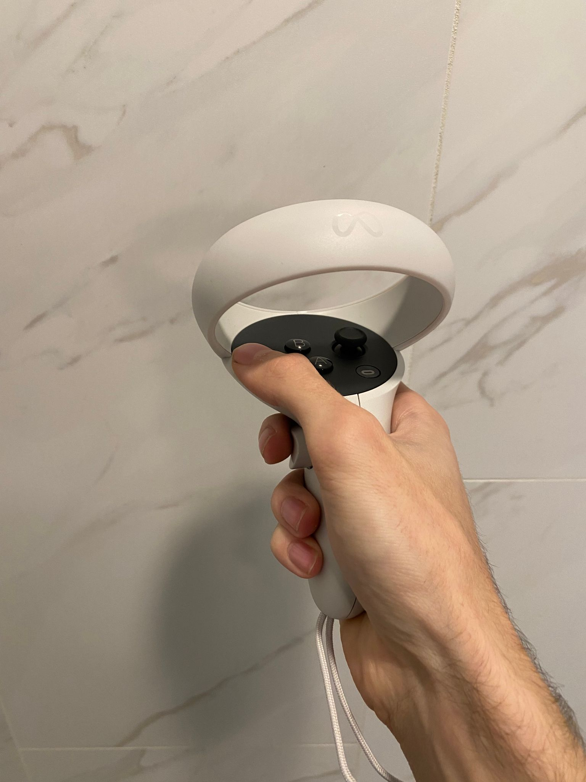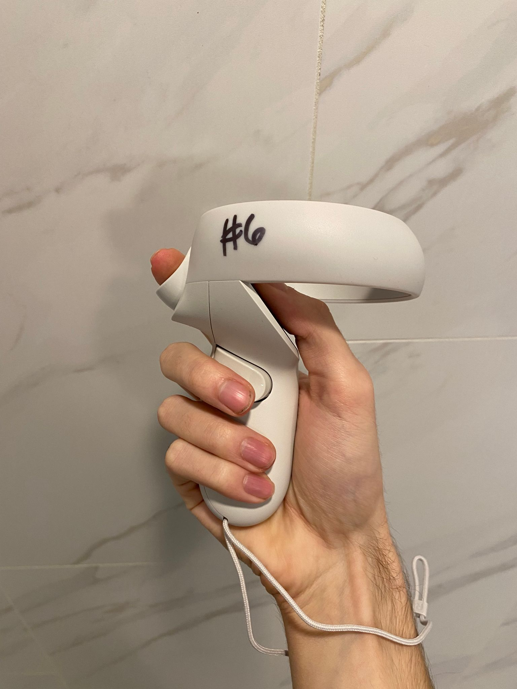
Always use hand-strap
Press either trigger at any time to move to next room
Use the thumbstick to move around

Appendix D
"Post-Experience Comfort Survey"
This post-experiment survey will be administered inside of the headset anonymously, with the only data being recorded with the survey is whether the participant is a member of the control or the experimental group.

- I felt at ease in the environment most similar to a supermarket.
Strongly agree agree neutral disagree strongly disagree
- I felt at ease in the environment most similar to an office building.
Strongly agree agree neutral disagree strongly disagree
- I felt at ease in the environment most similar to a classroom
Strongly agree agree neutral disagree strongly disagree

